**Betaglycan as a Potential Regulator of TGF-β1 Signalling in the Kidney**

Dr. Mohamed Al-helfawa*, Prof. Aled Phiillipsb, Dr. Robert Steadmanc

*.a,b,cInstitute of Nephrology. School of Medicine. Cardiff University. Heath Park Cardiff. CF14 4XN*

*aEmail: helfawi_65@yahoo.com, bEmail: phillipsao@cardiff.ac.uk, cEmail: steadmanr@cardiff.ac.uk*

**Abstract**

Before going deeper and deeper to study the kidney and its roles, let’s explain the main points that affects mechanisms through which it works. We start with transforming growth factor β1 (TGF-β1), which is a multifunctional growth factor with an important role in development, cell proliferation, matrix deposition, modulation of the, immunity, regulation of embryonic development and cellular differentiation and apoptosis (programmed cell death). It is considered as a significant mediator of glomerular and tubulointerstitial pathobiology in chronic kidney diseases[1]. Over-expression of TGF-β can induce renal fibrosis, causing kidney disease, and ultimately end-stage renal disease (ESRD). Recent developments have found that, using certain types of protein antagonists such as a receptor ligand or drug that does not induce a biological response itself upon binding to a receptor but sequential activation of two serine/threonine kinase receptors, the type I and type II receptors. A third receptor, betaglycan serves as a co-receptor for TGF-β1. Recent reports indicate that membrane anchored betaglycan may play an inhibitory role in TGF-β1 signalling. This inhibitory role of betaglycan is a function of the heparan sulphate composition of the betaglycan glycosaminoglycan [2]. We can say that, the expression of betaglycan and its augmentation by cytokines treatment in HK2 cells has been described. By concentrating on TGF-β activity, it is shown that knock-down by siRNA and inhibition of glycoslation of betaglycan antagonize signalling by TGF-β end production of EMT. This work suggests that betaglycan could be a major mediator of PTC activation in vivo. blocks reverse the effects of renal fibrosis [3].

***Keywords:*** α-SMA;(Alpha- Smooth Muscle Actin). DNA; (Deoxyribonucleic Acid). ECM; (Extracellular Matrix). EMT; (Epithelial-Mesenchymal Transition). GAPDH; (Glyceraldehyde-3-phosphate dehydrogenase). HK-2 (Human Kidney-2). mRNA; (Messenger Ribonucleic Acid). PAGE; (Polyacrylamide Gel Electrophoresis). PCR; (Polymerase Chain Reaction). P-Smad;(Phosphorylated-Smad). Q- PCR; (Quantitative PCR). RNA; (Ribonucleic Acid). RT- PCR; ( Reverse transcriptase-PCR). TGF-β; (Transforming growth factor-Beta).

------------------------------------------------------------------------

* Corresponding author.

1. **Introduction**

Tubulointerstitial fibrosis is a well-known finding of chronic renal disease, irrespective of the aetiology of the diseases and is considered as the major lesion of end-stage renal diseases such as glomerulonephritis as a primary inflammation, diabetic nephropathy as a metabolic dysfunction, and cystic nephropathy as structural malformations. The normal interstitium is a complicated structure of collagen, fibronectin, non-collagenous glycoproteins and proteoglycans. Interstitial fibrosis is characterized by excessive synthesis and accumulation of these and other ECM substances [4]. Thus the intersitium expands causing derangement of tubulointerstitial structure and changes of the normal physiological function and subsequently gradual deterioration of renal function. Progressive loss of renal function is associated with development of glomerulosclerosis and with interstitial fibrosis as well. Interstitial fibrosis is characterized by the destruction of renal tubules and interstitial capillaries as well as by the accumulation of extracellular matrix proteins [5]. As inerstitial fibrosis, related to accumulation of ECM , it also related to progression of renal disease with accumulation of fibroblasts and myofibroblasts which is related to nephron loss and kidney shut down, so considered as a predictor of fibrotic progression [6]. Moreover, previous studies have shown that reduction in the glomerular filtration rate is better correlated with tubulointerstitial injury than with glomerulosclerosis) [7].

Several factors, including cytokines and growth factors such as Transforming Growth Factor βI (TGF-βI) activate tubular cells and lead to this pathogenesis. Activated tubular cells secrete increased amounts of chemokines and cytokines into the peritubular interstitium. Activated tubular cells may themselves increase the formation of peritubular extracellular matrix as well [8].

Immune responses of tubular epithelial cells are induced by exposure to proteins e.g. stimulation of the release of various cytokines, including TGF-β1[9]. The release of such cytokines causes differentiation of tubular epithelial cells and possibly tubular epithelial cells into myofibroblasts. This change of phenotype is characterized by de novo expression of alpha-smooth-muscle actin [10]. A specific gene Fsp1 (fibroblast-Specific Protein-1) [11], has been cloned, which triggers the transformation of tubular epithelial cells into myofibroblasts [12], in response to cytokines, such as TGF-β. Studies revealed that tubulointerstitial disease was a more reliable predictor of functional impairement than was glomerular injury in a variety of renal diseases e.g. membranoproliferative glomeriulonephritis, diabetic glomeriulosclerosis, glomerular amyloidosis etc.[13].

Different sources of fibroblasts in organ fibrosis. Four possible mechanisms are depicted. One study suggests that about 12% of fibroblasts are from bone marrow, about 30% can arise via local EMT involving tubular epithelial cells under inflammatory stress, and about 35% are from EndMT [14]. Activation of resident fibroblasts or other mesenchymal cells, such as perivascular smooth muscle cells/pericytes and fibrocytes [15]. The remaining percentage likely emerge via proliferation of the resident fibroblasts and other still unidentified sources. Systemic treatment of mice with renal fibrosis with recombinant human BMP-7. The bone morphogenetic proteins (BMPs) reverses renal disease due to severe attenuation of the formation of EMT- and EndMT-derived fibroblasts. EMT is a process usually associated with an increase in cell motility and fibrotic sequelae with the accumulation of a newly expressed extracellular matrix (ECM). Various signalling pathways are involved in EMT. Some proteins are transcriptional repressors of E-cadherin and their expression induces EMT. Recently, activation of the phosphatidylinositol 3' kinase (PI3K)/AKT axis is emerging as a central feature of EMT [16]. A prototypical feature of epithelial cells undergoing an EMT‐process is reduced and finally lost expression of the epithelial marker E‐cadherin, a member of the adherent junction protein family[17].

1. **Materials and Methods**

Those have been used in this Abstract :

1. Conventional PCR.
2. Semi-Quantitative Polymerase chain reaction.
3. Quantitative Polymerase chain reaction (Q-PCR).
4. Western Blot Analysis.
5. Reporter Gene Analysis.
6. Statistical Analysis.

These methods have been shown in each experiment in this abstract.

***2.1.Transforming Growth Factor Beta TGF-β***

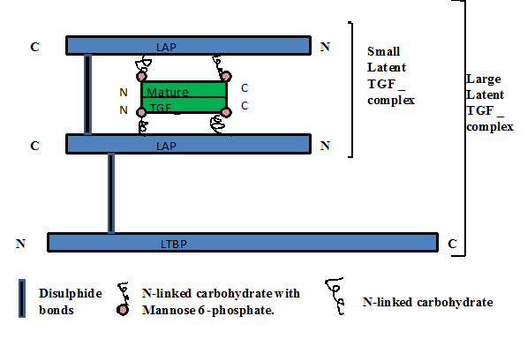

**Figure 1:** Shows the structure of Transforming Growth Factor Beta with its N and C terminals with small and large latent complexes.

**Adapted from: www.biochemj.org/bj/352/0601/bj3520601f01.jpg, Rahmi ÖKLÜ, and Robin HESKETH**

* 1. ***Adapted from : researchblogs.duke.edu/jas83***

There are five receptors regulating SMADs: SMAD1, SMAD2, SMAD3, SMAD5, and SMAD9 (sometimes referred to as SMAD8) figure 2 above. There are essentially two intracellular pathways involving these R-SMADs. TGF beta's, Activins, Nodals and some GDFs (Growth and differentiation factors (GDFs) are mediated by SMAD2 and SMAD3, while BMPs (Bone morphogenetic proteins ), AMH(Anti-mullerian hormone) and a few GDFs are mediated by SMAD1, SMAD5 and SMAD9. Binding of transforming growth factor beta (TGF-β) to its cell surface receptor Type II leads to the phosphorylation of the Type I receptor by Type II. The Type I receptor is then able to phosphorylate and activate the SMAD2 protein. Smad2, with Smad4, is translocated to the nucleus where the activated Smad complex recruits other biological effects of TGF-b, the above explained pathway called the classical signalling pathway of TGF-β (Figure 4). There are also Smad-independent pathways activated by TGF binding its receptors as Rho,MAPK,PKC,Cross-talk TGF-β signalling and Wint pathways.

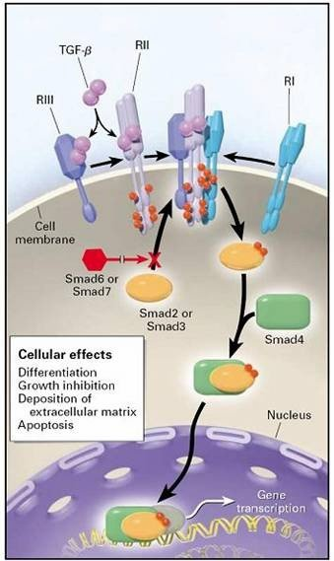

**Figure 2:** Signalling Pathways of TGF-β. The classical signalling pathway

* 1. ***Betaglycan (TGF-β RIII)***

Betaglycan is Transforming Growth Factor Beta receptor III (TGFBR3), (figure-3) and identified as an accessory receptor for the TGFβs is a cell-surface chondroitin sulfate / heparan sulfate proteoglycan, its molecular weight is about >300 kDa.(figure 3,10). It is a transmembrane proteoglycan with a large extracellular domain that binds TGF-β with high affinity but lacks a cytoplasmic signaling domain [18]. It is formed from heparin and chondroitin sulphate, core protein, ectodomain part, with its N and C terminals binding to ECM and cytoskeleton (Figure 3). Betaglycan binds to various members of the TGF-beta of ligands by its superfamily core protein, and bFGF (basic fibroblast growth factor), via its heparan sulfate chains. It is not involved directly in TGF-beta signal transduction but by binding to different member of the TGF-beta superfamily at the Cell surface, it acts as a reservoir of ligand for TGF-beta receptors[19].

Betaglycan is known to be a proteoglycan TGF-β co-receptor for TGF-β ligands, it is undergoes ectodomaine cleavage and production of a soluble ectodomain fragment which is stable in presence of betaglycan and if we treat the cells that express betaglycan with inhibitors of intramembrane protease γ-secretase, it stabilizes this fragment means that it is a γ-secretase substrate, all of these are independent of the effects of TGF-β.

So transmembrane-cytoplasmic fragment will be stable after betaglycan cleavage, this gives rise to an implication for TGF-β effects and response.

Betaglycan is important regulator of development, differentiation and tumor metastasis, it modulates some effects of TGF-β, it binds the three TGF-β isoforms through two binding sites on the core ectodomain also enhances TGF-β signalling by increasing affinity of the ligand forTGF-βII, on the other hand, it has also an inhibitory function by binding to TGF-β members. Betaglycan undergoes ligand-independent ectodomain shedding and a stable soluble fragment is produced which sequesters TGF-β. This fragment has got a therapeutic significant in some tumors and fibrosis as an inhibitor of TGF-β signaling. In addition to the betaglycan ectodomain it has also cytoplasmic domain which modulates TGF-β dependent and independent activation of p38/MAPK which still not well known, betaglycan also forms a complex with syndcan-2 which is important in regulating TGF-β signalling and fibrosis.

So investigations to explore the fate of betaglycan fragment after ectodomain cleavage is our target, so betaglycan ectodomain cleavage considered a substrate for γ-secretase and betaglycan transmembrane-cytoBetaglycan is known to be a proteoglycan TGF-β co-receptor for TGF-β ligands, transmembrane-cytoplasmic fragment will be stable after betaglycan cleavage, this gives rise to an implication for TGF-β effects and response.

Endogline despite of being functionally important, it is found in two forms, its mutation yields impaired coordination of TGF-β signalling complexes and play a role in controlling cell migration and adhesion composition.

Ectodomain shedding and γ-secretase-dependent release of an intracellular domain, an implication is important TGF-β signal transduction, on the other hand γ-secretase inhibition also has a significant impact on TGF-β signalling.

Betaglcan species have opposing effects on TGF-β signalling whereby betaglycan serving as ( molecular switch) .when isolated betaglycan cytoplasmic domain is inhibited it leads to decrease TGF-β signaling through activation of the p38/MAPK pathway, so betaglycan has got an essential role in mediating the specificity of TGF-β signaling pathways.

The structure of betaglycan,(figure 3) is a polymorphic membrane-anchored proteoglycan with high affinity for transforming growth factor-β (TGF-β). As produced from its cDNA sequence, the 853 amino acid core protein of betaglycan has an extracellular domain with different sites for glycosaminoglycan (GAG) chains attachment.

Despite these chains not being necessarily important for TGF-β binding to the core protein, they are an important component of connective tissues, and may be covalently linked to a protein to form proteoglycans.



**(Adapted online at www.med.unibs.it/%7Eairc/hspgs.htm).**

**Figure 3:** Structure of betaglycan

Betaglycan appears to deliver TGF-β to the signaling receptors [20]. Betaglycan binds TGF-β through the core protein [21]. The localization of the TGF-β-binding site in betaglycan is unclear. There are at least two independently active TGF-β binding sites in betaglycan, one in the N-terminal two thirds of the extracellular domain of betaglycan and another in the C-terminal one-third. These binding sites exhibit similar binding specificities and representing the N-terminal and C-terminal binding sites enhance the bioactivity of TGF-β. This enhancing effect was observed not only in the growth

inhibitory activity of TGF-β but also in the stimulating effect of TGF-β on the matrix

synthesis. In addition to a membrane-bound form, there is a soluble form of betaglycan as well, generated by the ectodomain shedding of the cell surface receptor. Although the membrane-bound form presents ligand, the soluble form is thought to sequester ligand from the serine/threonine TGF-ß signalling receptors.

This sequestering role may be of benefit in later stage tumours, where excess TGF-β may assist in tumour growth by enhancing epithelial to mesenchymal transitions, MMP (Matrix metalloproteinase) expression, and basement membrane degradation [22].

Furthermore, betaglycan, a cell surface heparan sulphate proteoglycan, is traditionally thought to function by binding transforming growth factor type β (TGF-β) via its core protein and then transferring the growth factor to its signalling receptor, the type II receptor. Betaglycan induces TGF-β signalling in a ligand-independent manner, through activation of the p38 pathway).

* 1. ***Betaglycan and Renal fibrosis***

Transforming growth factor-β (TGF-β) is a key mediator in the pathogenesis of renal diseases. Betaglycan, which is a type III TGF-β receptor and regulates TGF-β action by modulating its access to the type I and II receptors. Betaglycan potentiates TGF-β; however, soluble betaglycan, which is produced by the shedding of the membrane-bound receptor, is a potent antagonist of TGF-β. This was documented to prevent renal damage in genetically obese and diabetic db/db mice, Because SBG (Soluble betaglycan) has a high affinity for all TGF-β isoforms, in particular TGF-β2, it is found naturally in serum and tissues and its shedding may be regulated. It is believed that SBG will prove convenient for long-term treatment of kidney diseases and other pathologies in which TGF-β plays a pathophysiological role, as it occurs as a Proteoglycan Heparan sulfate (HS) which is a linear polysaccharide found in all animal tissues. It occurs as a PG in which two or three HS chains are attached in close proximity to cell surface or extracellular matrix proteins[23].

The major cell membrane HSPGs are the transmembrane syndecans (GPI) anchored glypicans. Other forms of membrane HSPG include betaglycan and the glycosylphosphatidylinositol [24] .

In contrast to membrane betaglycan, SBG inhibits TGF-β binding to kinase receptors and thereby works as a TGF-β antagonist [25]. The administration of SBG to db/db mice, resulted in a reduction in kidney damage, Plasma creatinine concentration, albuminuria, and mesangial matrix expansion, [26], were significantly reduced by the treatment with SBG, So it has been shown that SBG treatment of db/db mice significantly ameliorates the progression of kidney dysfunction, without any apparent negative side effect, as indicated by the absence of gross macroscopic damage of internal organs[27].

Betaglycan (BG) has a dual role in the modulation of TGF-β activities (Figure 4). BG, potentiates TGF-β actions when it is membrane bound. Shedding of BG extracellular region generates the soluble form of the receptor. Soluble BG still binds TGF-β with the high affinity of the membrane BG, but instead of presenting it to the type II receptor, soluble BG sequesters it and thus neutralizes its actions[28]. Unique among other TGF-β inhibitors is the fact that BG may be subject to regulated shedding of its ectodomain [29], making possible, in principle, control of the relative ratio of the membrane and soluble forms of the receptor, providing a way to switch TGF-β actions on or off. SBG is a renoprotective agent that neutralized TGF-β actions in this model of nephropathy. Because SBG has a high affinity for all TGF- isoforms, in particular TGF-β 2, it is found naturally in serum and tissues and its shedding may be regulated. We believe that SBG will prove convenient for long-term treatment of kidney diseases and other pathologies in which TGF- plays a pathophysiological role [30]. As inerstitial fibrosis, related to accumulation of ECM , it also related to progression of renal disease with accumulation of fibroblasts and myofibroblasts which is related to nephron loss and kidney shut down, so considered as a predictor of fibrotic progression [31]. This myofibroblasts express alpha smooth muscle actin that is related to intracellular stress fibres, in advanced disease, the interstitium becomes filled with myofibroblasts. Myofibroblasts are derived from a variety of sources including resident mesenchymal cells, epithelial and endothelial cells which is called epithelial/endothelial-mesenchymal (EMT/EndMT) transition, and from circulating fibroblast-like cells called fibrocytes that are derived from bone-marrow stem cells [32] . There is also what is called exosomes which could trigger elevated α-smooth muscle actin expression and differentiate fibroblast into myofibroblasts, this exosomes are vesicles secreted by diverse cell types that play complex roles in intercellular communication. Betaglycan did not alter TβRI or TβRII but instead inhibit Smad 2/3, Akt and ERK phosphorylation and we can say that betaglycan is important for TGF-β signalling and differentiation in myofibroblast, through smad dependent and independent pathways. While the Smad pathway is essential for TGF-β singnaing it also signal a variety of Smad-independent pathways as mitogen–activated protein kinase ( MAPKs ) and phosphatidylinositol 3-kinase (P13k)-Akt. Betaglycan is a transmembrane proteoglycan and shows a large extracellular domain which having heparin and chondroitin sulphate glycosaminoglycan chain but without kinase domain.



**Figure 4:** Betaglycan has a dual modulation of TGF-β activities

Betaglycan has an important function in cancer and lost in most of non-small cell lung cancer, its downregulation enhances epithelial to mesenchymal transition ( EMT ), betaglycan is downregulated during TGF-β differentiation of fibroblasts and this imply the antifibrotic action of betaglycan. Betaglycan undergoes ligand-independent ectodomain shedding and a stable soluble fragment is produced which sequesters TGF-β. This fragment has got a therapeutic significant in some tumors and fibrosis as an inhibitor of TGF-β signaling. In addition to the betaglycan ectodomain it has also cytoplasmic domain which modulates TGF-β dependent and independent activation of p38/MAPK which still not well known, betaglycan also forms a complex with syndcan-2 which is important in regulating TGF-β signalling and fibrosis.

Betaglcan species have opposing effects on TGF-β signalling whereby betaglycan serving as ( molecular switch) . when isolated betaglycan cytoplasmic domain is inhibited it leads to decrease TGF-β signaling through activation of the p38/MAPK pathway, so betaglycan has got an essential role in mediating the specificity of TGF-β signaling pathways. Genetic analysis to clarify the role of epithelial cells and interstitial cells in the generation of myofibroblasts during kidney injury and fibrosis. It has been shown that there is a definitive evidence that kidney epithelial cells do not become myofibroblasts in vivo, but show that interstitial pericytes are myofibroblast progenitors in fibrotic kidney disease [33,34].

* 1. ***The Aim of this work***

The purpose of work is to examine the potential role of betaglycan in HK2 cells as a regulator of TGF-β signalling in the kidney in terms of expression, inhibition and any phenotypical changes such as Epithelial-mesenchymal transition associated.

The specific aims are to:

1. Examine the expression and inhibition of betaglycan.

2. Examine the effect of specific siRNA and heparin sulphate inhibitors on betaglycan expression with relation to Smad phosphorylation of TGF-β.

3. Examine the role of betaglycan expression on α-sma and E-cadherin (EMT).

4. These roles of betaglycan actions will have a potential impact on TGF-β, which is the key factor in renal fibrosis.

* 1. ***Induction of betaglycan by proximal tubular cells***

The progression of renal disease is correlated with the degree of renal interstitial fibrosis. It has already been demonstrated that proximal tubular epithelial cells (PTC) have the potential to contribute to the pathogenesis of renal fibrosis directly by alterations in the production of components of the extracellular matrix and indirectly by the production of profibrotic cytokines [35;36], and we can see betaglycan expression by Cytokines and TGF-β by different methods,( figures 4,5) :



**Figure 5:** Betaglycan Expression by Conventional PCR

* 1. ***Conventional PCR showing betaglycan expression as bands on agarose gel following No stimulation, following IL-1 and following IL-6 stimulation compared with actin bands***

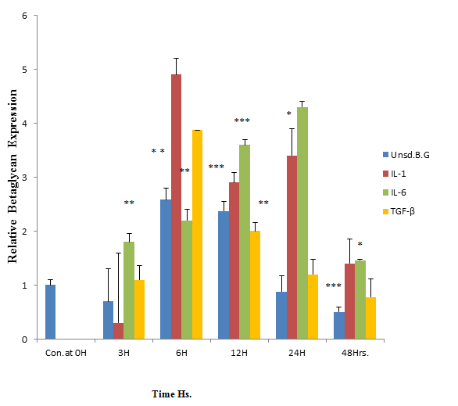

**Figure 6:** Conventional PCR Confirmation by Quantitative (Q-PCR), Concentration dependent induction (IL-1, IL-6 and TGF-β) of betaglycan expression

To identify the most effective dose of IL-1, IL-6 or TGF-β that produced the greatest betaglycan expression, different concentrations of cytokines were used to stimulate HK2 cells at the optimal time which was chosen as 12 hours.The results revealed that 0.5 ng/ml was the most effective dose for both IL-1 and IL-6 to produce maximum betaglycan expression while 10 ng/ml was the most effective dose for TGF-β (Figures 7,8,9) :

**Figure 7:** Dose Dependent of IL-1 Dose

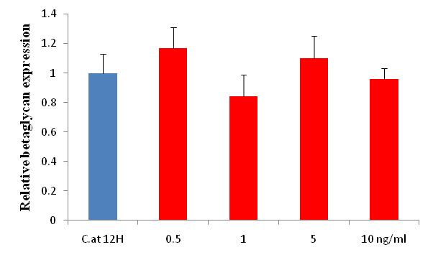

**Concentration of IL-6**

**Figure 8:** The most effective dose of the cytokine (IL6) induced BG express. at 12 hours’:

**Figure 9:** The most effective dose of the cytokine (TGF-β) induced betaglycan expression at 12 hours’ time point

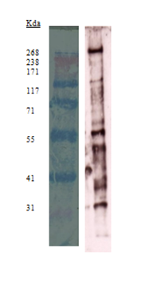

**Figure 10:** Betaglycan and its degradation products

**HiMarkTM Betaglycan and its Degredation products.**

* 1. ***Inhibition of Betaglycan Expression and Glycosylation***

knock-down of betaglycan was achieved by using specific short interfering RNA (siRNA) to investigate the optimal time of betaglycan knock-down, what happened to TGF-β1 signalling and any phenotypical changes to the immortalized HK2 cells. Whether the glycosylation of betaglycan was also important for its function was investigated using P-nitrophenyl-β-D-xylopyranoside to inhibit glycosylation.

* 1. ***Optimising Transfection Time***

The incubation time required for maximal knockdown of the target gene can vary depending on the specific siRNA used, and therefore the optimal transfection time for betaglycan was determined prior to further experimentation.Betaglycan was knocked-down by transfection with specific siRNA.

In the following experiment, determination of the optimal time of knock-down will help; namely at what time TGF-β can be best controlled by betaglycan.

The concentration of betaglycan siRNA was 20 mmolar, the scramble concentration was 40 pmol per microlitre and the end concentration was 33 nm/well.

The degree of TGF-βIII knock-down was measured by Q-PCR. Cells were transfected with siRNA and mRNA extracted for times up to 72 hours.

Knock-down was found to be maximal at 12 hours onwards (Figure 11). At 24 hours 80% knock-down which was highly significant (Figure 11).



**Figure 11:** Optimising Transfection Time

* 1. ***The bar graphs showing the best time for betaglycan knock-down, every group done individually and compared to its own scramble***

The effect of betaglycan siRNA on Smad-III phosphorlation was also carried out by SDS-PAGE and Western blotting was revealed a significant change of P-smad-III phosphorylation (Figure 12).

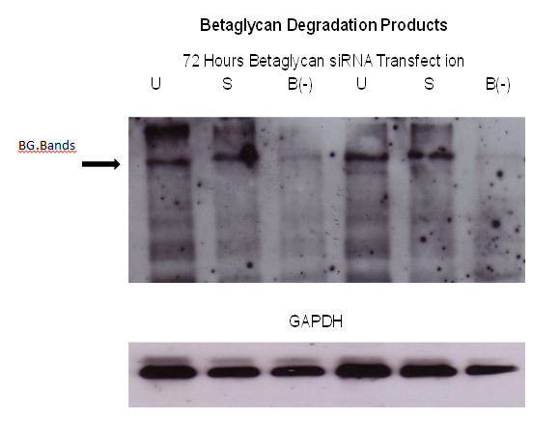

**Figure 12:** Betaglycan core protein inhibition by betaglycan siRNA transfection

Starting with the growing of HK2 cells until they become 50% confluent, they were kept in serum free media overnight then transfected with siRNA and incubated for 72 hours.

The cells were then extracted for protein analysis by SDS-PAGE and Western blotting carried out.

There was a marked reduction in betaglycan protein expression in knocked-down cells (Figure 13), Samples were compared to GAPDH. U = untransfected samples, S = Scrambled, B(-) = betaglycan knock-down.

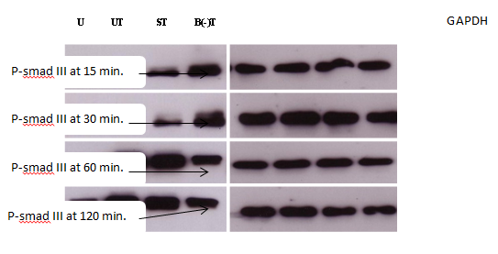

**Figure 13:** Here betaglycan prevents P-smad III of being expressed. HK2 cells were transfected and 30 Western blotting carried out. GAPDH has been used for comparison. ST = Scramble + TGF-β, B(-)T = betaglycan knock-down + TGF-β. The relationship of betaglycan knock-down on TGF-β signalling in terms o P-smad-III phosphorylation changes which were used at different time intervals.

* 1. ***The relationship between betaglycan and TGF-β1 signalling following treatment with P-nitrophenyl-β-D-xylopyranoside (Dual Luciferase Enzyme Reporter)***

The dual luciferase reporter assay (Promega) has been used to show how inhibition of betaglycan heparan sulphate with P-nitrophenyl-β-D-xylopyranoside regulates and affects TGF-β signalling (Figure 14).

Removal of betaglycan heparan sulphate in epithelial cells increases the ratio of TGF-β1 binding to TβR-II and TβR-I, attenuates degradation of TGF-β1.

augments TGF-β1 -induced cellular responses but this action depends on the magnitude of TGF-β as it has been known that around one-quarter of TGF-β has been shown to bind to heparan sulphate [43].

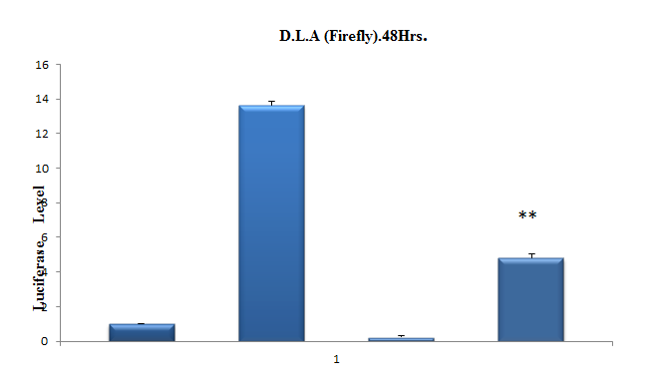

**Figure 14:** The relation between BG and TGF-β following P-N-Xpyranoside

Preparing the white 96 well plate, 12 wells + 2 blank + 1 extra = 15 wells, dose of P-nitrophenyl-β-D-xylopyranoside is 0.406 milligram per 500 microlitre in each well, and for Tgf-β is 1 microlitre per ml which is equal to 1 ng per ml. Cells transfected with the CAGA-luciferase reporter construct, treated with P-nitrophenyl-β-D-xylopyranoside (single dose), Tgf-β stimulation was at 6 hours. Four groups used in the experiment (Control, Tgf-β, PXY, Both). The samples were incubated for 72 hours with the inhibitor. This experiment was repeated three times. ┬ = Standard deviation. * = P-value = ˂ 0.05 = Statistically significant = ˂ 0.05 , ** = P-value = highly significant = ˂ 0.03 , Control = Neither XY nor TGF-β was applied. XY = P-nitrophenyl-β-D-xylopyranoside.

As has been seen from the previous experiment (figure 14), the inhibition of the active part of betaglycan (Heparan sulphate) has brought down TGF-β luminescence level. These results suggest that heparan sulfate modulates TGF-β1 responsiveness by decreasing the ratio of TGF-β1, thus diminishing signalling of TGF-β1 in the epithelial cells[44].

Generally betaglycan has an important impact on TGF-β signalling as it affects the core protein expression and subsequently the cell functions, when betaglycan blocked, its bands down-regulated and phosphorylation of P-smad III has changed, which shows how significant betaglycan (TGF-β-R III) could manage TGF-β signalling in the kidney.

* 1. ***The effect of P-nitrophenyl-β-D-xylopyranoside treatment on betaglycan protein***

Betaglycan and TGF-β1 signalling association were examined by Dual Luciferase Enzyme Reporter assay with P-nitrophenyl-β-D-xylopyranoside treatment. Betaglycan protein was down regulated as seen by the Western blotting experiment which was regulated by treatment with P-nitrophenyl-β-D-xylopyranoside (Figure 15).

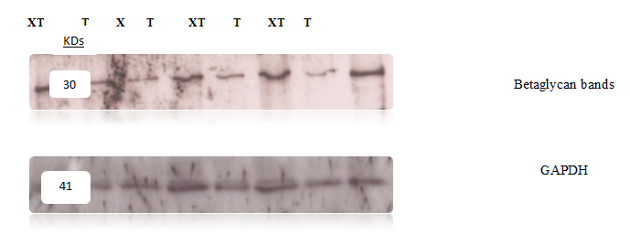

**Figure 15:** The effect of P-nitrophenyl-β-D-xylopyranoside treatment on betaglycan core-protein expression

Incubation period of P-nitrophenyl-β-D-xylopyranoside was 72 hours. The effect of P-nitrophenyl-β-D-xylopyranoside treatment (The betaglycan functional part inhibitor, heparan sulphate), as it affects betaglycan protein expression, results assayed with GAPDH. High molecular weight ladder was used to visualize the high molecular weight betaglycan size. This experiment was repeated 3 times and gave the same result. T = TGF-β, XT = P-nitrophenyl-β-D-xylopyranoside + TGF-β.

* 1. ***Effect of P-nitrophenyl-β-D-xylopyranoside treatment on P-Smad-III***

The purpose of this experiment was to show how P-nitrophenyl-β-D-xylopyranoside was affected TGF-β core-protein (the P-Smad-III) which was visualised by Western blotting. After transfection of HK2 cells with P-nitrophenyl-β-D-xylopyranoside treatment, stimulation with TGF-β was done at 15, 30, 60 and 120 minutes then scraping of the protein and proceeding to SDS-PAGE and Western blotting as described in the methods (section 2.11), which revealed a significant change of P-smad-III phosphorylation, results assayed by GAPDH, and here supports that P-nitrophenyl-β-D-xylopyranoside through inhibition of heparan sulphate, betaglycan core protein and subsequently TGF-β found to be down regulated [45], as shown in (Figure 16).

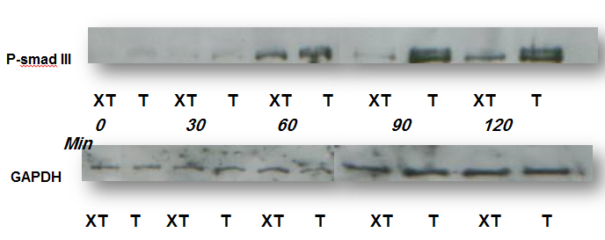

**Figure 16:** Effect of P-nitrophenyl-β-D-xylopyranoside treatment on P-smad-III

* 1. ***The Function of Betaglycan***

The potential impact of betaglycan as a marker of epithelium (E-cadherin) or mesenchymal cells (α-sma) is studied in this chapter. Cadherins are calcium-dependent adhesion molecules and members of a class of type-1

transmembrane proteins. They have important roles in cell adhesion and contribute to mechanisms controlling how cells within tissues are bound together.

The cadherin superfamily includes cadherins, protocadherins, desmogleins, and desmocollins. In structure, they share cadherin repeats, which are the extracellular Ca2+-binding domains [46], Loss of both E-cadherin expression and function, has been implicated in cancer progression and metastasis. E-cadherin down-regulation decreases the strength of cellular adhesion within a tissue, resulting in an increase in cellular motility. This in turn may allow cancer cells to cross the basement membrane and invade surrounding tissues.Actin is the monomeric subunit of two types of filaments in cells: microfilaments, one of the three major components of the cytoskeleton, and thin filaments, part of the contractile apparatus in muscle cells. Thus, actin participates in many important cellular processes including muscle contraction, cell motility, cell division and cytokinesis, vesicle and organelle movement, cell signalling, and the establishment and maintenance of cell junctions and cell line. Alpha smooth muscle actin is a protein that in humans is encoded by the ACTA2 gene located on 10q22-q24 [47]. The alpha smooth actin is found in muscle tissues and is a major constituent of the contractile apparatus[48]. It can be used for evaluation of the disease activity and prognosis as its expression increased by mesangial cells from GN patients in the kidneys [49]. The expression of α-smooth muscle action (α-SMA) in the renal tubulointerstitium in patients with kidney collateral stasis was increased with the increasing of the degree of renal interstitial fibrosis, as there was a significant positive correlation between kidney collateral stasis and α-SMA expression [50] . So expression of alpha-smooth-muscle actin (ASMA) has suggested a new way to assess clinical implications in the kidney.The effect of betaglycan on TGF-β- dependent phenotypical changes in human immortalized HK2 has been examined (Figure 17). The effect of knock down of betaglycan on E-cadherin and alpha-smooth-muscle actin has been used to investigate whether the effect of betaglycan on TGF-β induced signalling resulted in changes in markers of EMT.

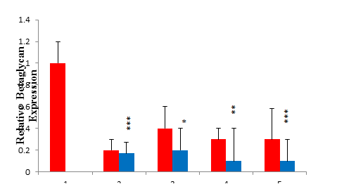

**Figure 17:** Demonstration of the HK2 cell functions in terms of betaglycan expression after being knocked-down then stimulated by TGF-β:

This Q-PCR bar graph illustrates betaglycan Expression after betaglycan knock-down then TGF-β stimulation at different time points, every sample compared to the scramble.

* 1. ***Demonstration of E-cadherin expression by HK2 cells after betaglycan knock-down and TGF-β stimulation***

E-cadherin expression as an element of EMT in HK2 cells was investigated after betaglycan knock-down in the presence of TGF-β stimulation to examine whether there was an association of betaglycan with EMT. The result was that, E-cadherin was down regulated when betaglycan down regulated or lost (figure 18) which suggested that there was an element of EMT in most of the time points.

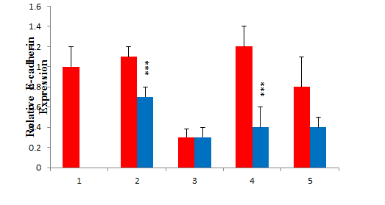

**Figure 18:** Q-PCR illustrates E-cadherin expression after BG knock-down and TGF-β stimulation

Q-PCR illustrates the E-cadherin expression after betaglycan knock-down and TGF-β stimulation at different time points, every sample compared to the scramble one

* 1. ***Demonstration of α-sma expression of HK2 cells after betaglycan knock-down and TGF-β stimulation***

Alpha smooth muscle actin expression as an element of EMT in HK2 cells was investigated after betaglycan knock-down in the presence of TGF-β stimulation to examine whether there was an association of betaglycan with EMT. This is done by Real-time quantitative PCR(figure 19). The result of α-sma was mildly up-regulated which suggested that there was an element of EMT when betaglycan was lost.

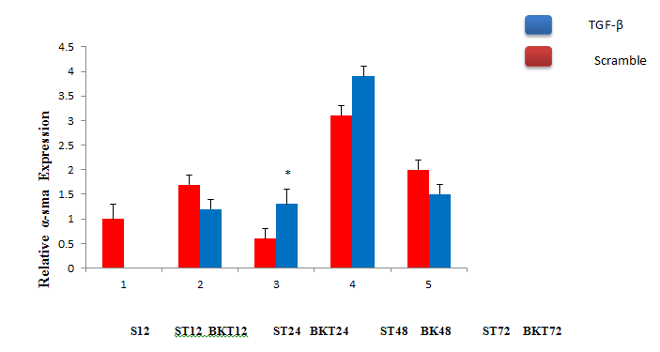

**Figure 19:** Q-PCR illustrates α-sma expression after betaglycan knock-down and TGF-β stimulation

* 1. ***Relationship of betaglycan to PAI-1( Plasminogen activator inhibitor-1)***

The purpose of the experiment was to determine whether betaglycan knock-down induced TGF-β down regulation as a direct action or through PAI-1 which is the mean TGF-β inducer. In this experiment, when TGF-β applied, PAI-1 expression increased that means betaglycan knock-down does not depends on PAI-1 action.Type-1 inhibitor of plasminogen activator (PAI-1) is an important physiological regulator of extracellular matrix (ECM) homeostasis and cell motility. TGF-β1, in particular, is a powerful inducer of matrix deposition/turnover, cell locomotion and PAI-1 expression. Plasminogen activator inhibitor-1 is the main inhibitor of tissue plasminogen activator (tPA) and urokinase (uPA), the activators of plasminogen and hence fibrinolysis. High levels of PAI-1 are found in severe sepsis while low levels or deficiency are found in bleeding. Thus plays a role in inflammatory lung disease and malignancy. It has an important role in renal disease where high levels of PAI-1 are found in nephritic and haemolytic uremic syndrome.

The following experiment, tries to determine the relationship between PAI-1 and betaglycan, and as TGF-β induces PAI-1, (figure 20). Starting the experiment which lasts 48 hours in triplicate samples, mRNA was isolated, reverse transcribed, then quantified by Real-time quantitative PCR. The result of PAI-1 was down regulated but when TGF-β was given, PAI-1 expression was increased, that means PAI-1 has no relationship with betaglycan when it acts on TGF-β which instead it has been induced leading to relatively increased PAI-1 expression (Figure 20).

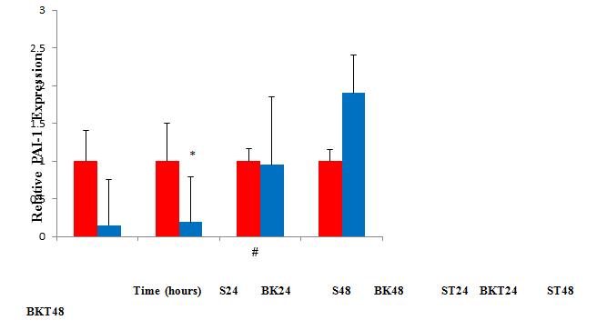

**Figure 20:** Plasminogen activator inhibitor-1 and BG. Relationship

The above is Q-PCR Paragraph of PAI-1 Expressions following betaglycan knock-down with and without Tgf-β stimulation at different time points, every sample compared to the scrample one.

Fibrosis might occur in a variety of organs which are mainly composed of epithelial cells, such as kidney, lung and the liver[51] . Inflammatory signals derived from proliferating interstitial fibroblasts and inflammatory cells lead to an expanded ECM and fibrosis. The analyses of diseased human kidney biopsies, revealed the appearance of EMT markers [52] . There is also the generation of myofibroblasts by the proximal tubular epithelial cells via EMT[49] . In addition, there is evidence in‐vitro that EMT phenotypes occur in different non‐malignant epithelial cells of different origin. This includes renal, hepatic and pulmonary cells in which a process associated with the expression of mesenchymal marker proteins which can be induced by different stimuli as TGF-β and Proteinase-activated receptors (PARs). [53].

TGF-β, α-sma and E-cadherin have a relationship with betaglycan regarding its expressions and knock-down. All of these subsequently have an impact on HK2 cells. TGF-β produced a high level of betaglycan expression, and this was shown in the previous chapters but when betaglycan knocked-down, its expression dropped down, that means TGF-β biological activity can be controlled. Transforming growth factor-β (TGF-β) is a key mediator in the pathogenesis of renal diseases but TGF-β activity has been reduced during betaglycan knock-down, so kidney diseases and fibrosis can be reduced. This renoprotective advantage of betaglycan is induced by its soluble form which binds TGF-β with the high affinity of the membrane betaglycan, but actions [instead of presenting it to the type II receptor, soluble betaglycan sequesters it and thus neutralizes its 54].

E-cadherin and α-sma expression can also be explored when betaglycan knocked-down. That was evident when samples compared to the 1st scramble did occur during EMT, with E-cadherin expression reduced while α-sma expression was increased and that supports EMT as an effect of betaglycan knock-down, this effect was found to be mild, and this is where the role of betaglycan comes, its presence will reduce EMT effect.

Once the relationship of betaglycan and TGF-β signalling was determined and TGF-β is an inducer of PAI-1, betaglycan̕s relationship with PAI-1 could also be studied, and there was no direct action, but when TGF-β was applied, PAI-1 expression increased and that supports the argument that betaglycan has no relation with PAI-1 but a direct action with TGF-β which is the mean inducer of PAI and there might be other mechanisms have been involved as cells were more reactive to TGF-β. It has clearly been shown in this chapter that betaglycan has an important role in reducing epithelial-mesenchymal transformation (EMT).

1. **General Discussion**

The aim of this thesis was to explore the role of betaglycan as a potential regulator of TGF-β signalling in the kidney. It has been found that betaglycan has been expressed by human PTC in culture either without stimulation or when PTC stimulated at the level of the mRNA or at protein level and this could be inducible by the cytokines namely IL-1, IL-6 and TGF-β, this emphasises the potential importance of betaglycan in PTC (Proximal tubular cells) as a contributor to the pathogenesis of renal fibrosis either by alteration of extracellular matrix or by production of profibrotic cytokines such as IL-1, IL-6 and TGF-β. These cytokines have significant cell interaction with betaglycan and its activation, and therefore provide different degrees of expression.

Since HK2 cells express betaglycan, so do the cytokines (IL-1, IL-6 and TGF-β), this result supports the argument that betaglycan expression is essential for optimal TGF-beta signalling. These have been proved by Conventional PCR and confirmed by Q-PCR where betaglycan has shown a maximum expression during 24 hours. Other cells such as colon goblet cells express normal levels of betaglycan protein [55], Cardiac endothelial cells that undergo epithelial-mesenchymal transformation express betaglycan [56]. Now this has also been seen with HK2 cells of the kidney. On the other hand, instead of expression, betaglycan can be knocked-down by betaglycan siRNA transfection or interference with its heparin sulphate composition, which considered to be as a beneficial effect of betaglycan, an example of that was in treating fibrosis as its knock-down reduce TGF-β expression in mediating fibrosis. Another example where it inhibits the fibrous airway obliteration in a rat model of Bronchiolitis obliteran [57]. Furthermore, betaglycan knock-down is resulted in decreased growth and motility of human breast cancer, both in vitro and in vivo [58]. This knock-down has been determined at what time that can be best achieved.

It has been shown that betaglycan was necessary for mediating TGF-β1 signalling through Smad 3 phosphorylation and that heparan sulphate was also crucial for TGF-β1. It was also demonstrated that the TGF-β1 induced change in phenotype depended on betaglycan expression and heparan sulphate synthesis.

On the opposite angle of the scale, loss of betaglycan contributes to the pathogenesis of GCTs (Granulosa cell tumour), [56], and other cancers. Defining the physiological function and mechanism of betaglycan action and alterations in betaglycan activity during cancer progression should allow more effective targeting of betaglycan and betaglycan mediated functions for the diagnosis and treatment of human cancer [59]. Betaglycan might play a prominent role in development and progression of NSCLC (non-small cell lung cancer) and correlate with NSCLC invasion and migration as its expression observed to be reduced [60].

Human betaglycan mRNA is negatively regulated by TGF-β1 in ovarian and breast cancer cells. This regulation is dependent on TβRI/ALK5(ALK5 = TGF-β receptor gene) and occurs at the transcriptional level on the betaglycan gene [58]. Loss of betaglycan expression can cause ovarian and other cancers, this seems to be due, at least in part, to genetic silencing [59]. Furthermore, betaglycan expression is frequently decreased or lost in human cancers (i.e. 65% of breast cancers and 60% of prostate cancers).

An oncogenic role for betaglycan in human breast cancer cells and mouse mammary tumour cells has been shown by Knock-down of betaglycan in these cells and it resulted in decreased growth and motility, both in vitro and in vivo [61]. Betaglycan suppresses cancer progression, in part, by reducing cancer cell motility, this betaglycan function is independent of its betaglycan signalling role, but with betaglycan activating Cdc42 via its interaction with the scaffolding protein beta-arrestin 2 to re-organize the actin cytoskeleton, reduce directional persistence and prevent random migration in both epithelial-derived cancer cells and normal epithelial cells [62].

Decreased betaglycan expression could be one of the most common mechanisms for TGFβ resistance in human cancers. Importantly, increasing or restoring expression of betaglycan in these cancer models decreases cancer cell motility and invasion in vitro and angiogenesis, invasion, and metastasis in vivo [63].

On the other hand, betaglycan, is a widely expressed heparan and chondroitin sulfate proteoglycan that binds TGF-β with high affinity through its protein core. Changing glycoslation of betaglycan can be achieved by p-nitrophenyl-β-D-xylopyrinoside treatment. It does not affect the protein levels of TβR-I binding TβR-II in Mv1Lu cells by Western blot analysis. Heparan sulphate however negatively modulates TGF-β by decreasing the ratio of TGF-β1 binding to TβR-II and TβR-I [64 ]. In HK2 cells, the Luciferase reporter assay, revealed that P-nitrophenyl-β-D-xylopyranoside brought up TGF-β induced luminescence and led to TGF-β up-regulation. This implies that inhibition of betaglycan heparan sulphate by P-nitrophenyl-β-D-xylopyranoside affects TGF-β signalling.

All of these affect the TGF-β signalling function of HK2 cells of the kidney in terms of physical and biochemical function as TGF-β protein expression of its signalling has already been changed, and this shows the link between betaglycan and TGF-β.

Although normally membrane anchored, betaglycan can undergo proteolytic processing in vivo resulting in the secretion of a soluble ectodomain. This ectodomain can both enhance and inhibit signalling depending on the concentration of TGF-β1 present, although in most circumstances it is believed to bind and sequester TGF-β, functioning as a receptor antagonist. In the kidney, these effects have reduced renal damage progression. This emphasises that the relationship between betaglycan and TGF-β1 signalling is complicated because the former has shown different regulatory mechanisms upon TGF-β action.

It was believed that SBG (Soluble betaglyccan) shall prove convenient for long-term treatment of kidney diseases and other pathologies in which TGF-β plays a pathophysiological role [65]. Soluble betaglycan, which is produced by the shedding of the membrane-bound receptor, is a potent antagonist of TGF-β. inhibitory, but as tumorigenesis progresses, TGF-β becomes prometastatic [66].

In this thesis, experiments and results of betaglycan mRNA and core protein were knocked-down and this alteration has a role in HK2 cells transition or transformation in terms of minimal loss of expression of the epithelial marker E‐cadherin expression changes, and also mildly increased cytoskeletal proteins α‐SMA (signs of EMT).

Epithelial cells are typically characterized by intercellular adhesion complexes in their lateral membranes which enable them to be closely attached to each other and to form cell layers. They display an apico-basal polarity, and are separated by the basement membrane from

other tissues in the body. In contrast to epithelial cells, mesenchymal cells are capable of moving individually through the extracellular matrix since they lack intercellular junctions,and do not display an Apico‐Basal-polarity [67].

Cells that have undergone EMT reveal changes in their migratory capacity and responses to external signals [68]. Not only signalling function, but changes of function as well (EMT) as there was a down regulation of betaglycan, mild E-cadherin and α-sma changes, that might be attributed to the Inhibition of Smad2 expression with a failure of TGF-β1 to increase α-SMA , confirming the involvement of this signalling in phenotypic activation [68]. In contrast, successful knockdown of Smad3 using siRNA failed to have an impact on TGF-β1-mediated phenotypic differentiation [69]. In immortalised HK2 cells, PAI-1 expression decreased when betaglycan knocked-down and when TGF-β was applied, and PAI-1 expression increased; that might be attributed to the fact that PAI-1 has no relationship with betaglycan or PAI-1 has another pathway of action despite being turned up by TGF-β.

1. **Limitations**

There are some limitations in this work which must be taken into account: Firstly, p-nitrophenyl-β-D-xylopyrinoside analysis has been used to suppress betaglycan heparan sulphate, and this action is not specific for betaglycan as it might inhibit all heparan of other structures (off target). This will have an impact on the result of the experiment as heparan sulphate inhibition might be incompleteSecondly, soluble betaglycan has not been studied in this work, and if we did, there would have been many results arising from the association of both soluble as well as membranous portion of betaglycan, both of which could have resulted in further action on TGF-β, the SBG sequester TGF-β while the membranous part heparan sulphate acts as a reservoir of ligand for TGF-beta receptors.Thirdly, this work used immortalized HK2 cells as a predictor of renal fibrosis, but the other predictor of outcome in the kidney, regardless of disease aetiology, is the presence of myofibroblasts which was not studied. Finally, this work also needs to be applied to and practiced in animal research to get the best results, as the HK2 cells have been grown in their normal environment and could express any change that might happen in vivo.

1. **The overall conclusion**

Betaglycan can be expressed by HK2 cells spontaneously or by inflammatory cytokines and can also be inhibited by siRNA, P-nitrophenyl-β-D-xylopyranoside, and ameliorate fibrosis as well as cancer through a group of multiple regulatory mechanisms towards TGF-β1 signalling and also could contributes to EMT. Betaglycan acts as apotential regulator of TGF- β1 signalling in the kidney.

1. **Recommendations**

These groups of betaglycan actions will have a potential impact on TGF-β, which is the key factor in renal fibrosis and when combined together they will provide a new weapon in the treatment of kidney fibrosis.

**References**

[1] .Bottinger E. P, Bitzer M ( 2002). TGF-beta signaling in renal diseaseˮ J Am Soc Nephrol. 2002 Oct;13(10):2600-10.

[2] .Chen C.L., Huang S.S., and Huang J.S. (2006). Cellular heparan sulfate negatively modulates transforming growth factor-beta1 (TGF-beta1) responsiveness in epithelial cells. J Biol Chem. Apr 28;281(17):11506-14.

[3]. Hopkins A.L., and Groom C.R. (2002). The druggable genome. Nature reviews. Drug discovery, 1(9):727-30.

[4] .Downer G., Phan S. H., et al. (1988). Analysis of renal fibrosis in rabbit model of crescentic nephritis Clin Invest 82(3): 998-1006

[5] .Fukagawa M., Noda M., Shimizu T., and Kurokawa K. (1999) Chronic progressive interstitial fibrosis in renal disease—are there novel pharmacological approaches?, Nephrol Dial Transplant 14: 2793-2795.

[6].Soma Meran and Robert Steadman, Fibroblasts and myofibroblasts in renal fibrosis. 2011 https://doi.org/10.1111/j.1365-2613.2011.00764.x.

[7] .Bohle A., Muller GA., Wehrmann M., Mackensen-Haen S, et al (1996). Pathogenesis of chronic renal failure in the primary glomerulopathies, renal vasculopathies, and chronic interstitial nephritides. Kidney Int, 54: S2-9.

[8] .Wang Shi-Nong., and Hirschberg Raimund.(1999), Tubular epithelial cell activation and interstitial fibrosis. The role of glomerular ultrafiltration of growth factors in the nephrotic syndrome and diabetic nephropathy. Nephrol Dial Transplant , 14: 2072-2074.

[9] Strutz . Novel aspects of renal fibrogenesis. Nephrol Dial Transplant (1995) 10: 1526-1532

[10] Nahas A.M.E., Muchaneta-Kubara E.C., Zhang G., Adam A., et al. (1996 ), Phenotypic modulation of renal cells during experimental and clinical renal scarring. Kidney Int; 49: S23-27.

[11] Struz F., Okada H., and Lo C.W., et al.( 1995). Identification and characterization of a fibroblast marker: FSP1. J Cell Biol; 130: 393–405.

[12]Yang J., and Weinberg R.A. (2008). Epithelial-mesenchymal transition: at the crossroads of development and tumor metastasis. Dev Cell 14(6):818-829.

[13] Bohle A., Muller GA., Wehrmann M., Mackensen-Haen S.,et al. (1996). Pathogenesis of chronic renal failure in the primary glomerulopathies, renal vasculopathies, and chronic interstitial nephritides. Kidney Int, 54: S2-9.

[14] Kalluri R., Neilson E.G. Epithelial-mesenchymal transition and its implications for fibrosis. J. Clin. Invest. 2003;112:1776–1784. [PMC free article] [PubMed]

[15] Zavadil J., Bottinger E.P. TGF-beta and epithelial-to-mesenchymal transitions. Oncogene. 2005;24:5764–5774. doi: 10.1038/sj.onc.1208927. [PubMed] [Cross Ref].

[16] Vernon A., and LaBonne C. (2004). Tumor metastasis: a new twist on epithelial-mesenchymal transitions. Current Biology 14: 719–21.

[17] Hay E.D., and Zuk A. (1995). Transformations between epithelium and mesenchyme: normal, pathological, and experimentally induced. Am J Kidney Dis, 26(4):678-690.

[18] Lopez-Casillas F., Wrana J.L., Massague J. (1993). Betaglycan presents ligand to the TGFβ signalingreceptor. Cell 73: 1435-1444.

[19] Andres J.L., DeFalcis D., et al. (1992). Binding of two growth factor families to separate domains of the proteoglycan betaglycan. J. Biol. Chem, 267(9):5927-5930.

[20] Lopez-Casillas F., Wrana J.L., Massague J. (1993). Betaglycan presents ligand to the TGFβ signaling receptor. Cell 73: 1435-1444.

[21] Sergarini, P. R. and Seyedin, S. M. (1988) J. Biol. Chem. 263, 8366±837.

[22] Bjorklund M., and Koivunen E. (2005). Gelatinase-mediated migration and invasion of cancer cells. Biochim Biophys Acta, 1755(1):37-69.

[23] Gallagher J.T., and Lyon M. (2000). Molecular structure of Heparan Sulfate and interactions with growth factors and morphogens. In Iozzo M.V. (ed). Proteoglycans: structure, biology and molecular interactions. New York. Marcel Dekker Inc. pp. 27-59.

[24] Vilchis-Landeros M.M., Montiel JL., Mendoza V., Mendoza-Hernández G.,et al . ( 2001). F. Recombinant soluble betaglycan is a potent and isoform-selective transforming growth factor neutralizing agent. Biochem J 355: 215–222.

[25] Andres J.L., DeFalcis D., et al. (1992). Binding of two growth factor families to separate domains of the proteoglycan betaglycan. J. Biol. Chem, 267(9):5927-5930.

[26] Cohen, M.P., Sharma K., Jin Y., Hud E., et al. (1995). Prevention of diabetic nephropathy in db/db mice with glycanated albumin antagonists: a novel treatment strategy. J Clin Invest 95: 2338-2345.

[27] Juárez P., Vilchis-Landeros M.M., Ponce-Coria J., Mendoza V., et al (2006), (Soluble betaglycanreduces renal damage progression in db/db mice).Am J Physiol Renal Physiol 292:F321-F32.

[28] López-Casillas F., Payne H.M., Andres J.L., Massague J. (1994). Betaglycan can act as a dual modulator of TGF-β access to signaling receptors: mapping of ligand binding and gag attachment sites. J Cell Biol 124: 557-568.

[29] Velasco-Loyden G., Arribas J., and López-Casillas F. (2004). The shedding of betaglycan is regulated by pervanadate and mediated by membrane type matrix metalloprotease-1. J Biol Chem 279: 77217733.

[30] Juárez P., Vilchis-Landeros, Ponce-Coria J. and López-Casillas F. (2006), (Soluble betaglycan reduces renal damage progression in db/db mice). Am J Physiol Renal Physiol 292:F321-F32.

[31] Crisan M, Yap S, Casteilla L, Chen CW, 2008;3:301–313. [PubMed].

[32] John Willey, 2007

[33] Plotkin MD, Goligorsky MSAm J Physiol Renal Physiol. 2006;291:F902–F912. [PubMed]

[34]. Phillips A.O., Steadman R., and Topley N., et al.(1995). Elevated D-glucose concentrations modulateGF-β1 synthesis by human cultured renal proximal tubular cells: The permissive role of plateletT derived growth factor. Am J Pathol .147: 362−374.

[35] Phillips A.O., Topley N., and Morrisey K et al. (1997). Basic fibroblast growth factor stimulates the release of pre-formed TGF-β1 from human proximal tubular cells in the absence of de-novo g transcription or mRNA translation. Lab Invest .76: 591−600.

[36] Ehiers M. R. W., and Riordan J. F. (1991). Membrane proteins with soluble counterparts: role of proteolysis in the release of transmembrane proteins. Biochemistry. 30:10065-10074.

[37] Isaka Y., Tsujie M., Ando Y, et al (2000).Transforming growth factor-beta1antisenseoligodeoxy nucleotides block interstitial fibrosis in unilateral ureteral obstruction. Kidney Int, 58:1885-1892.

[38] Han D.C., Hoffman B.B., Hong S.W., Guo J,.,et al. (2000) . Therapy with antisense TGF-beta1oligodeoxy nucleotides reduces kidney weight and matrix RNAs in diabetic mice. Am J Physiol Renal Physiol, 278(4):F628-634.

[39] Ji C., Chen Y., McCarthy T. L., Centrella M. (1999). Cloning the Promoter for Transforming GrowthFactor-b Type III Receptor. J. Biol. Chem. 274:30487-30494.

[40] Centrella, M., Casinghino S., Kim J., Pham T, et al. (1995).Independent changes in type I and type II receptors for transforming growth factor beta induced by bone morphogenetic protein 2 parallel expression of the osteoblast phenotype. Mol. Cell. Biol, 15:3273-3281.

[41] Kohan D.E. (1991). Endothelin synthesis by renal tubule cells.Am J Physiol 261(2 Pt 2): F221-6.

[42] Rider C.C. (2006 ). Heparin/heparan sulphate binding in the TGF-beta cytokine superfamily. Biochem Soc Trans. 34(Pt 3):458-60.

[43] Chun-Lin Chen., Shuan Shian Huang., and Jung San Huang. (2006). Cellular Heparan SulfateNegatively Modulates Transforming Growth Factor-β1(TGF-β) Responsiveness in Epithelial Cells.The journal of biological chemistry. Vol. 281, NO. 17, pp. 11506-11514.

[44] Hulpiau P., and van Roy F. (2009). Molecular evolution of the cadherin superfamily. Int. J. Biochem.Cell Biol, 41(2):349-69.

[45] Angst B., Marcozzi C., and Magee A. (February 2001). The cadherin superfamily: diversity in form and function. J Cell Sci, 114(Pt 4):629-41

[46] Ueyama H., Bruns G.,and Kanda N. (1990). Assignment of the vascular smooth muscle actin gene ACTSA to human chromosome 10. Jinrui Idengaku Zasshi 35 (2): 145–50.

[47] Chebotareva N.V., Proppe D., Rudolf P., and Kozlovskaia LV.( 2002). Clinical significance of expression of the smooth muscle actin-alpha and CD34 antigen in mesangial cells in glomerulonephritis. Ter Arkh, 74(6):27-31.

[48] De Autocrine and Exogenous Transforming Growth Factor (TGF) ß1 in Cells with Nonfunctional TGF-ß Receptor Type III. (Cell Growth & Differentiation Vol. 10, 11-18. ng X., Bellis S., Zhongfa Yan., and Eileen Friedman. (1999). Differential Responsiveness to

[49] Brown C. B., Boyer A. S., Runyan R. B., Joey V., et al. (1999). Requirement of Type III TGF-β Receptor for Endocardial Cell Transformation in the Heart. American Journal Experts. Vol. 283. no. 5410, 2080 - 2082.

[50] YANG Dong; DU Yong-ping, 2008. Yang J., and Weinberg R.A. (2008). Epithelial-mesenchymal transition: at the crossroads of development and tumor metastasis. Dev Cell 14(6):818-829.

[51] Liu M., Suga M., Maclean A.A., St George J.A.,et al. (2002). Solubletransforming growth factor-beta type III receptor gene transfection inhibits fibrous airway obliteration in a rat model of Bronchiolitis obliterans. Am J Respir Crit Care Med. 1.165(3):419-

[52] Criswell T.L., Dumont N., Joey V., Barnett., et al . (2008). Knockdown of the Transforming Growth Factor-β Type III Receptor Impairs Motility and Invasion of Metastatic Cancer 6307. Cells. Cancer Res. Carlos L. Arteaga, Division of Oncology, Vanderbilt University Medical Center, TN 37232.

[53] Iwano M., Plieth D., Danoff T.M., Xue C., et al (2002). Evidence that fibroblasts derive from epithelium during tissue fibrosis. J Clin Invest, 110(3):341-350

[54] Bilandzic M., Chu S., Farnworth P.G., Harrison C.,et al. (2009). Loss of Betaglycan Contributes to the Malignant Properties of Human Granulosa Tumor Cells. Molecular Endocrinology, 23(4):539-548.

[55] Willis B.C., and Borok Z. (2007). TGF-beta-induced EMT: mechanisms and implications for fibrotilung disease. Am J Physiol Lung Cell Mol Physiol 293(3):L525-53.

[56] . Gatza C.E., Oh S.Y., and Blobe G.C. (2010). Roles for the type III TGF-beta receptor in human cancer Cell Signal. 22(8):1163-74.

[57] . Jiang X., Liu R., Lei Z., You J., Zhou Q. et al. (2010). Defective expression of TGFBR3 gene and its molecular mechanisms in non-small cell lung cancer cell lines. 13(5):451-7.

[58] . Hempel N., How T., Cooper S.J., Green T.R., et al (2008). Expression of the type III TGF-β receptor is negatively regulated by TGF-β. Carcinogenesis, 29(5):905-912.

[59] . Dong M., How T., Kirkbride K.C., et al. (2007)The type III TGF-ß receptor suppresses breast cancer progression. J Clin Invest;117:206-17.

[60] . Criswell T.L., Dumont N., Joey V., Barnett.,et al. (2008). Knockdown of Transforming Growth Factor-β Type III Receptor Impairs Motility and Invasion of Metastatic Cancer Cells. Cancer Res. Carlos L. Arteaga, Division of Oncology, Vanderbilt University Medical Center, TN37232-6307.

[61] . Mythreye K and Blobe G.C. (2009) .The type III TGFbeta receptor regulates directional migration: new tricks for an old dog. Cell Cycle. 8(19):3069-70. Epub2009 Oct 8.

[62] . Dong M., How T., Kirkbride K.C., et al. (2007)The type III TGF-ß receptor suppresses breast cancer progression. J Clin Invest;117:206-17.

[63] . Chen C.L., Huang S.S., and Huang J.S. (2006). Cellular heparan sulfate negatively modulatetransforming growth factor-beta1 (TGF-beta1) responsiveness in epithelial cells. J Biol Chem. 28;281(17):11506-14.

[64] . Juárez P., Vilchis-Landeros M.M., Ponce-Coria J., Mendoza V.,et a.l (2006), (Soluble betaglycan reduces renal damage progression in db/db. Am J Physiol Renal Physiol 292:F321-F32

[65] . Criswell T.L., Dumont N., Joey V., Barnett.,et al. (2008). Knockdown of the Transforming Growth Factor-β Type III Receptor Impairs Motility and Invasion of Metastatic Cancer Cells. Cancer Res. Carlos L. Arteaga, Division of Oncology, Vanderbilt University Medical Center, TN 37232-6307.

[66] . Thiery J.P.,and Sleeman J.P. (2006). Complex networks orchestrate epithelial-mesenchymal transitions. Nat Rev Mol Cell Biol 7(2):131-142.

[67] . Gotzmann J., Mikula M., Eger A., Schulte-Hermann R.,et al. Molecular aspects of epithelial cell plasticity: implications for local tumor invasion and metastasis. Mutat Res 566(1):9-20.

[68] . Evans R.A, Tian Y.C., Steadman R., Phillips A.O. (2003).TGF-β1-mediated fibroblast-myofibroblast terminal differentiation-the role of Smad proteins. Exp Cell Res .282:90-100.

[69] . Simpson R.M.L., Stephens P., Steadman R., and Phillips A. (2010). Aging Fibroblasts ResistPhenotypic Maturation Because of Impaired Hyaluronan-Dependent CD44/Epidermal Growth Factor Receptor Signaling. American Journal of Pathology. 176:1215-1228.