Development of Android-Based Augmented Reality for Promotion of Jepara Tourist Attractions
Muhammad Faiz Al Izza^{a*}, Irma Handayani, S.Kom, M.Cs^{b}
^{a,b}University Technology of Yogyakarta, Indonesia
ªEmail:mfaizalizza@gmail.com
^{b}Email:Irma.handayani@staff.uty.ac.id
Abstract
Jepara Regency is an area rich in tourist attractions. By introducing tourist attractions to tourists who want to visit them, tourists will become more familiar with them and have the desire to visit them. Augmented reality is the technology of imaging virtual objects into the real world through a camera connected to a computer. The aim of this research is to implement augmented reality technology to increase the attractiveness of Jepara tourist attractions. Data was obtained through observation, interviews and documentation of tourists and the general public. By utilizing marker-based AR, promotion of Jepara tourist attractions can be clearly visualized and become effective introduction and information. This application can offer information on tourist attractions, accommodation and typical Jepara culinary delights. It is hoped that the development of promotional applications for Jepara tourist attractions can increase the attraction of tourists to visit Jepara and provide interesting experiences to visitors and have a positive impact on the regional economy and surrounding communities.
Keywords: Tourism Industry; Android; 3D Model; Tourism; Augmented Reality.
- Introduction
The tourism sector is an economic resource that has become a mainstay and development priority in a number of countries, especially for Indonesia. Indonesia has the potential of a vast region with great tourist attraction, with lots of natural beauty, various cultural historical heritage and people's daily lives. Tourist attractions are also one of the natural treasures that we can be proud of, because each region has its own uniqueness both in terms of natural beauty and customs that are able to attract tourists to visit it. One of them is a district in Central Java, namely Jepara Regency. However, the delivery of information about tourist attractions in Jepara Regency is limited to catalogs and pictures on social media, which means that not all tourists can get information easily.
------------------------------------------------------------------------
Received: 10/28/2023
Accepted: 12/28/2023
Published: 1/8/2024
------------------------------------------------------------------------
* Corresponding author.
On the other hand, many tourist attractions are relatively new and have not yet been exposed to tourists, for example the tourist attractions located on the slopes of Mount Muria have lots of beautiful natural views.
Seeing these conditions, we need a technology that is able to create an even distribution of tourist attraction recognition in Jepara Regency and is able to depict objects in real time. By utilizing technology that can be seen in an attractive, attractive, unique and contemporary way, tourists and the local community can get to know tourist attractions from the information provided by this application. This technology is Augemted Reality (AR) which can be used via Android smartphones.
Augmented Reality (AR) is a technology that combines virtual objects, both 2-dimensional and 3-dimensional, into a real environment and then projects these virtual objects in real time [6].
This research is expected to produce promotional applications for Jepara tourist attractions. This Android-based application uses the C# programming language and the Vuforia library. The author created the 3D model himself using sketch up software to adjust the alignment between 3D models if necessary. Apart from 3D objects, another feature of this application is 360º panoramic photos of tourist objects obtained from observations and the author documents directly at the tourist objects. Not only that, there are features about lodging information and typical Jepara culinary delights that tourists can visit.

- Literature Review
Research conducted by Farhany entitled "Augmented Reality Application as Information Media for the Fatahillah Museum and Puppet Museum Using the Markerless Method". The result of this research is an Android mobile application that can display images of the Fatahillah Museum building and the Jakarta Wayang Museum in 3D, equipped with text and video using Unity, the Vuforia library and markerless augmented reality as a medium for introducing the Fatahillah Museum and the Jakarta Wayang Museum [2].
The next research was carried out by Kristian regarding "Augmented Reality Visualization Application Learning Guide for Operating System Installation Using a Video Playback System". This research aims to help media for learning applications regarding the installation of Windows and Linux operating systems in the form of an addition to the printed module which will display video playback tutorials in digital form. This application was created using the Unity3D application using the C# programming language [3].
The next research was carried out by Kristian regarding "Augmented Reality Visualization Application Learning Guide for Operating System Installation Using a Video Playback System". This research aims to help media for learning applications regarding the installation of Windows and Linux operating systems in the form of an addition to the printed module which will display video playback tutorials in digital form. This application was created using the Unity3D application using the C# programming language [3].
The next research was carried out by Putri regarding "Arjuna: Application for Introduction to Tourist Attractions in East Java Based on Augmented Reality". This application uses photos and videos with 360 degree panoramas in the vuforia database. By opening the AR camera in the application and walking forward through the 3D door, AR objects will appear in the Vuforia database. The application displays photos and videos with a 360 degree panorama as a media for visualizing tourist attractions during the Covid-19 pandemic [4].The next research was carried out by Sangari regarding "Implementation of Augmented Reality Technology in Lalumpe Village to Realize a Digital Tourism Village". This research uses the marker base tracking method which can display and visualize tourism potential in 3D form. In making this application, it was made using several software, namely Unity3D, Blender 3D and Vuforia SDK [5].
- Research Method
- Research Stages
The research method in this research is the method used generally, namely the case study method which is divided into 2, namely data collection and software development (Augmented Reality). The general description of the method in this research is explained through several stages. The data collection method used in this research is collecting information from various sources related to research, for example books and journals. In Figure 1 it is explained the initial stage in making the application, namely observing tourist objects, then identifying what problems exist in the environment. After that, the researcher collected data such as literature studies from various kinds of literature studies, then the researcher began designing the application system and implementing Augmented Reality technology into the application system. In the final stage, the researcher tested the feasibility of the application being built, such as the display, buttons, system response and made conclusions in the research.
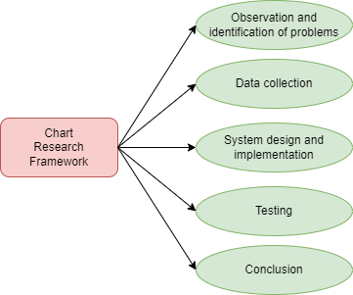
Figure 1: Chart Research Framework
- Required Analysis
In Figure 2, the initial condition of tourists is depicted only seeing catalogs and photos/videos. With these initial conditions, the researcher has a proposal to create an Android-based tourist attraction promotional media application. Figure 3 depicts the model or proposal proposed for building an application for the promotion of tourist attractions that applies Augmented reality technology. This application has features that can help tourists find out Jepara tourist attractions in detail and the application is made easy to use and attracts user interest.
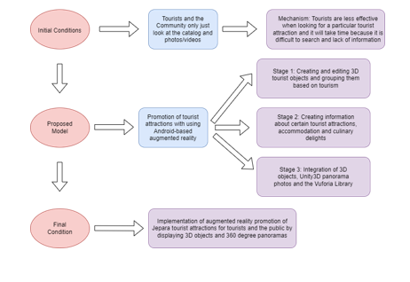
Figure 2: Required Analysis
- Use Case Diagram
A use case diagram is a diagram or description of the scenario of user interaction with the system and the function of the system. Below is a use case diagram created by the researcher. In Figure 3 the use case diagram starts with the main menu then there are several menus such as the StartAR Menu for the Augmented reality feature, the Lodging Menu to inform about lodging in Jepara, the Culinary Menu to inform about typical Jepara culinary delights, the Guide Menu to help users in using the application and the About Menu to researcher's personal data information.
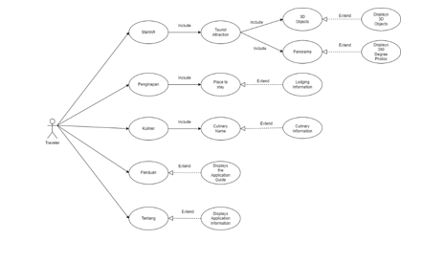
Figure 3: Use Case Diagram
- Activity Diagram
In the activity menu diagram, tourists start the stage by opening the application. After that, press the "StartAR" Menu button which will display 2 menus, namely the "3D Object" and "Panorama" menus. In the "3D Object" menu, the system will run the camera automatically by detecting targets in the form of flat areas and displaying real 3D objects. In the "Panorama" menu, users can see tourist objects 360 degrees along with written information and supporting audio.
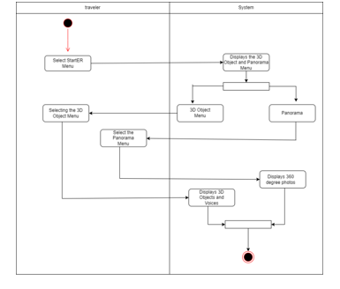
Figure 4: Activity Diagram
- Implementation
- Main Page Implementation
On the main page display several menu buttons appear, namely StartAR, Lodging, Culinary, Guide and about. These menus will lead to previously programmed displays.
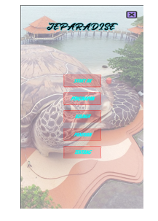
Figure 5: Main Menu Display
- StartAR Menu Implementation
Tampilan ini merupakan tampilan menu StartAR. Nantinya, pengguna ketika memilih menu "Objek 3D" akan langsung menampilkan tampilan AR dan kamera secara otomatis menyala, kemudian objek 3D akan tampil. Sedangkan menu "Panorama" pengguna dapat menikmati pemandangan foto secara 360 derajat beserta ada informasi tentang objek wisata.
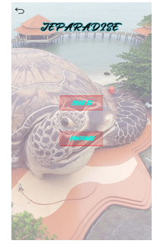
Figure 6: StartAR Menu
- Implementation of AR and Panorama Menus
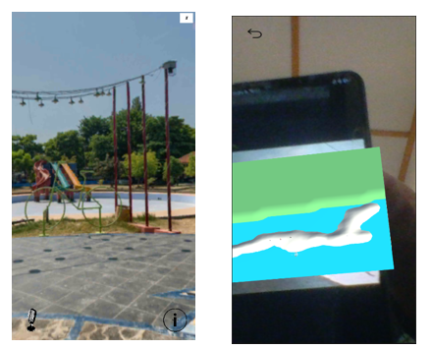
Figure 7: AR and Panorama Menu
- Implementation of Lodging Menu
This display displays the names of recommended lodgings and information about the lodgings starting from photos, prices, facilities, addresses (maps) and lodging reservations.
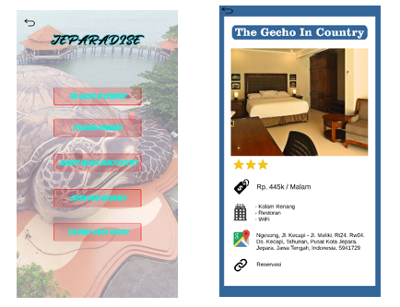
Figure 8: Lodging Menu
- Culinary Menu Implementation
This display displays typical Jepara culinary delights and there is information about these culinary delights.
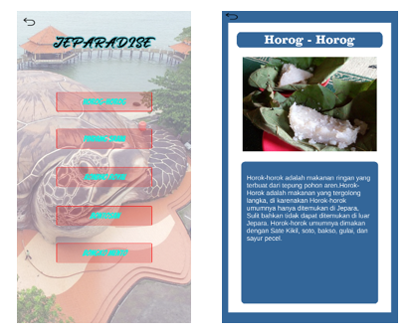
Figure 9: Culinary Menu
- Implementation of the Guide Menu
This display displays explanations of several menus so that tourists can use and understand the application.
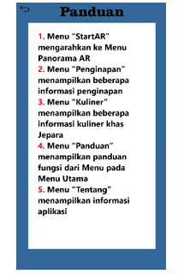
Figure 10: Guide
- Implementation of the About Menu
This view displays information about the application and researcher information.
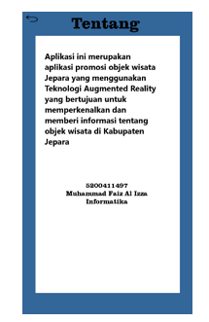
Figure 11: About Menu

- Testing
The results of Roger S. Pressman's Black Box testing explain that black box testing can focus on the functional requirements of a software or software to obtain a set of input conditions that will fully implement the functionalities of a program. Black box testing is carried out by running the application with the aim of finding errors or bugs and checking that the system can run well according to plan. The following black box test table for the Jepara tourist attraction AR application is as follows:
Table 1: Black Box Testing
NO | Testing | Expected results | Test results
1. | Main course | Displays the StartAR Menu, Lodging Menu, Culinary Menu, Guide Menu and About Menu | Succeed
2. | StartAR menu | Displays Several AR Menus | Succeed
3. | 3D Object Menu | Displays 3D tourist objects | Succeed
4. | Lodging Information Menu | Displays some detailed accommodation information | Succeed
5. | Culinary Menu | Displays some detailed accommodation information | Succeed
6. | Guide Menu | Displays guidance in the functions of each menu | Succeed
7. | About Menu | Displays an overview of the application/system | Succeed
The final testing stage is compatibility testing which is carried out on several smartphones to find out whether the application can run well and smoothly. The following are the results of the compatibility test which can be seen in the following table:
Table 2: Compatibility Testing Results
Device Name | Android version | Results
Samsung A30 | 11.0 | The application can run success
OPPO A3s | 8.0 | The application can run success
Redmi Note 8 Pro | 11.0 | The application can run success
Redmi 11 Pro | 11.0 | The application can run success
Redmi Note 11 | 13.0 | The application can run success
6. Conclusions
Based on research conducted by researchers, the following conclusions can be obtained:
- Implementation of augmented reality technology in the promotion of Android-based Jepara tourist objects designed and created to display 3D objects and 360 degree panoramas,
- This application has several menu features such as StartAR to start and display 3D objects and 36 degree panoramas. The lodging menu displays detailed lodging information starting from prices, facilities, prices to reservations. The culinary menu displays detailed information about typical Jepara culinary delights. The guide menu displays a function guide from the menu in the application. About menu to display information related to the application created.
- By designing and building this application, tourists can get information about the tourist attractions they want to visit and introduce tourist attractions to tourists.
References
- Dijaya, R., Bintara, W. S., & Fitrani, A. S. (2021). Wisata Alam Digital Di Kota Kediri Menggunakan Augmented Reality. JIPI (Jurnal Ilmiah Penelitian dan Pembelajaran Informatika), 6(2), 293–304. https://doi.org/10.29100/jipi.v6i2.2001
- Farhany, N. M., Andryana, S., & Komalasari, R. T. (2019). Aplikasi Augmented Reality Sebagai Media Informasi Museum Fatahillah Dan Museum Wayang Menggunakan Metode Markerless. Jurnal ELTIKOM, 3(2), 104–111. https://doi.org/10.31961/eltikom.v3i2.140
- Kristian, L. (2020). APLIKASI VISUALISASI AUGMENTED REALITY PANDUAN BELAJAR INSTALASI SISTEM OPERASI DENGAN MENGGUNAKAN SISTEM VIDEO PLAYBACK. Journal of Technopreneurship and Information System (JTIS), 2507(1), 1–9. https://doi.org/10.1016/j.solener.2019.02.027%0Ahttps://www.golder.com/insights/block-caving-a-viable-alternative/%0A???
- Putri, A. M., Safitri, M. I., Indah, R., & Mandasari, M. (2021). Arjuna : Aplikasi Pengenalan Tempat Wisata Di Jawa Timur. e-Proceeding of Applied Science :, 7(5), 1968–1973.
- Sangari, M. T., Tulenan, V., & Rumbayan, M. (2022). Implementation of Augmented Reality Technology Village. 11(2), 109–120.
- Agung Dzulfikar, I., Roedavan, R., & Siradj, Y. (2021). Pembuatan Aplikasi Media Pembelajaran Sistem Gerak Berbasis Augmented Reality Pada Smpn 1 Tambelang. Proceeding of Applied Science, 7(6), 3480.

